Lab 1: Understanding ORM with a Retail Inventory System
Product.cs
using System;
using System.Collections.Generic;
using System.Linq;
using System.Text;
using System.Threading.Tasks;
namespace RetailInventory
{
public class Product
{
public int ProductId { get; set; }

public string Name { get; set; }

public decimal Price { get; set; }

public int Stock { get; set; }
}
}

Category.cs
using System;
using System.Collections.Generic;
using System.Linq;
using System.Text;
using System.Threading.Tasks;
namespace RetailInventory
{
public class Category
{
public int CategoryId { get; set; }

public string Name { get; set; }
}
}

InventoryContext.cs
using System;
using System.Collections.Generic;
using System.Linq;
using System.Text;
using System.Threading.Tasks;
using Microsoft.EntityFrameworkCore;
namespace RetailInventory
{
public class InventoryContext : DbContext
{
public DbSet<Product> Products { get; set; }
public DbSet<Category> Categories { get; set; }
protected override void OnConfiguring(DbContextOptionsBuilder optionsBuilder)
{
optionsBuilder.UseSqlServer(
"Server=(localdb)\\MSSQLLocalDB;Database=RetailInventoryDB;Trusted_Connection=True;TrustServerCertificate=True");
}
}
}

Program.cs
using RetailInventory;
using var db = new InventoryContext();
// Create a new product
Product product = new Product
{
Name = "Laptop",
Price = 50000.00m,
Stock = 10
};
// Save it to the database
db.Products.Add(product);
db.SaveChanges();
Console.WriteLine("Product added successfully!");
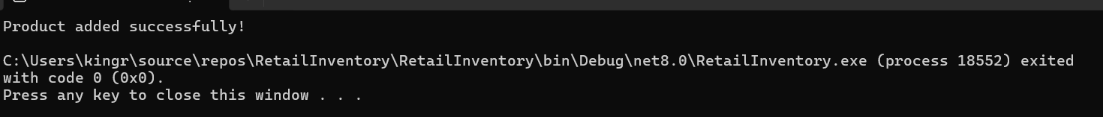

Program.cs
using RetailInventory;
using var db = new InventoryContext();
foreach (var product in db.Products)
{
Console.WriteLine($"ID: {product.ProductId}");
Console.WriteLine($"Name: {product.Name}");
Console.WriteLine($"Price: {product.Price}");
Console.WriteLine($"Stock: {product.Stock}");
Console.WriteLine("------------------------");
}
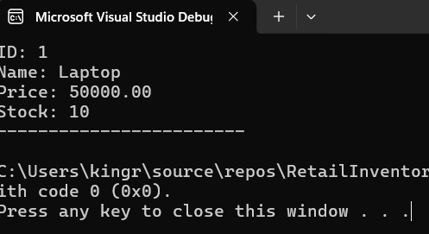

Lab 2: Setting Up the Database Context for a Retail Store
Category.cs
using System.Collections.Generic;
namespace RetailInventory
{
public class Category
{
public int Id { get; set; }

public string Name { get; set; }

public List<Product> Products { get; set; } = new List<Product>();
}
}

Product.cs
using System;
using System.Collections.Generic;
using System.Linq;
using System.Text;
using System.Threading.Tasks;
namespace RetailInventory
{
public class Product
{
public int Id { get; set; }
public string Name { get; set; }
public decimal Price { get; set; }
public int CategoryId { get; set; }
public Category Category { get; set; }
}
}
Program.cs
using System;
using RetailInventory;
namespace RetailInventory
{
internal class Program
{
static void Main(string[] args)
{
using var db = new AppDbContext();
// Create a Category
Category electronics = new Category
{
Name = "Electronics"
};
// Create a Product
Product laptop = new Product
{
Name = "Laptop",
Price = 50000,
Category = electronics
};
// Save to Database
db.Categories.Add(electronics);
db.Products.Add(laptop);
db.SaveChanges();
Console.WriteLine("Category and Product saved successfully!");
Console.ReadKey();
}
}
}

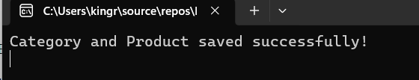

Program.cs
using Microsoft.EntityFrameworkCore;
using RetailInventory;
using var db = new AppDbContext();
var products = db.Products.Include(p => p.Category).ToList();
foreach (var product in products)
{
Console.WriteLine($"Product ID : {product.Id}");
Console.WriteLine($"Product Name : {product.Name}");
Console.WriteLine($"Price : {product.Price}");
Console.WriteLine($"Category : {product.Category.Name}");
Console.WriteLine("--------------------------------");
}
Console.ReadKey();
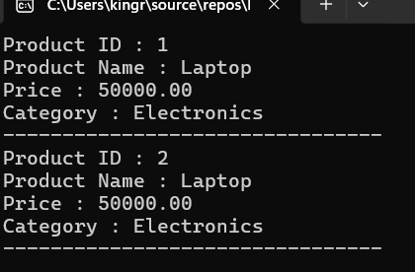

Lab 3: Using EF Core CLI to Create and Apply Migrations
Product.cs
using System;
using System.Collections.Generic;
using System.Linq;
using System.Text;
using System.Threading.Tasks;
namespace RetailInventory
{
public class Product
{
public int Id { get; set; }
public string Name { get; set; }
public decimal Price { get; set; }
public int CategoryId { get; set; }
public Category Category { get; set; }
}
}

Category.cs
using System.Collections.Generic;
namespace RetailInventory
{
public class Category
{
public int Id { get; set; }
public string Name { get; set; }
public List<Product> Products { get; set; } = new List<Product>();
}
}

Program.cs
using System;
using RetailInventory;
namespace RetailInventory
{
internal class Program
{
static void Main(string[] args)
{
using var db = new AppDbContext();
// Create a Category
Category electronics = new Category
{
Name = "Electronics"
};
// Create a Product
Product laptop = new Product
{
Name = "Laptop",
Price = 50000,
Category = electronics
};
db.Categories.Add(electronics);
db.Products.Add(laptop);
db.SaveChanges();
Console.WriteLine("Category and Product saved successfully!");
Console.ReadKey();
}}}
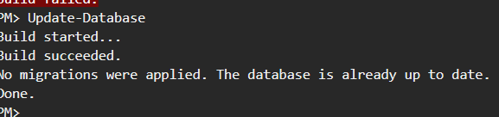
Lab 4: Inserting Initial Data into the Database
Program.cs
using RetailInventory;
using var context = new AppDbContext();
// Create Categories
var electronics = new Category
{
Name = "Electronics"
};
var groceries = new Category
{
Name = "Groceries"
};
// Insert Categories
await context.Categories.AddRangeAsync(electronics, groceries);
// Create Products
var product1 = new Product
{
Name = "Laptop",
Price = 75000,
Category = electronics
};
var product2 = new Product
{
Name = "Rice Bag",
Price = 1200,
Category = groceries
};
// Insert Products
await context.Products.AddRangeAsync(product1, product2);
// Save Changes
await context.SaveChangesAsync();

Console.WriteLine("Data inserted successfully!");
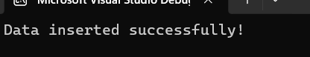

AppDbContext.cs
using Microsoft.EntityFrameworkCore;
namespace RetailInventory
{
public class AppDbContext : DbContext
{
public DbSet<Product> Products { get; set; }
public DbSet<Category> Categories { get; set; }
protected override void OnConfiguring(DbContextOptionsBuilder optionsBuilder)
{
optionsBuilder.UseSqlServer(@"Server=(localdb)\MSSQLLocalDB;Database=RetailInventoryDB;Trusted_Connection=True;TrustServerCertificate=True;");
}
protected override void OnModelCreating(ModelBuilder modelBuilder)
{
modelBuilder.Entity<Product>()
.Property(p => p.Price)
.HasPrecision(18, 2);
}
}
}

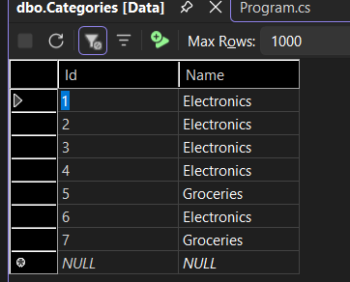
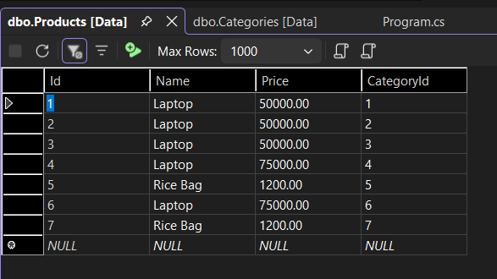

Lab 5: Retrieving Data from the Database
Program.cs
using Microsoft.EntityFrameworkCore;
using RetailInventory;
using var context = new AppDbContext();
// Retrieve all products
Console.WriteLine("----- All Products -----");
var products = await context.Products.ToListAsync();
foreach (var p in products)
{
Console.WriteLine($"{p.Name} - ₹{p.Price}");
}
// Find product by ID
Console.WriteLine("\n----- Find Product by ID -----");
var product = await context.Products.FindAsync(1);
Console.WriteLine($"Found: {product?.Name}");
// First product whose price is greater than 50000
Console.WriteLine("\n----- Expensive Product -----");
var expensive = await context.Products
.FirstOrDefaultAsync(p => p.Price > 50000);

Console.WriteLine($"Expensive: {expensive?.Name}");

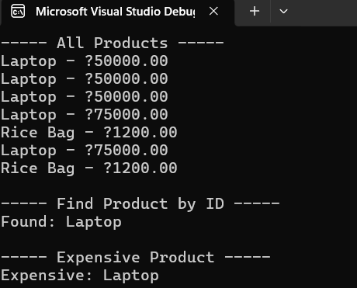

Lab 6: Updating and Deleting Records
Program.cs
using Microsoft.EntityFrameworkCore;
namespace RetailInventory
{
internal class Program
{
static async Task Main(string[] args)
{
using var context = new AppDbContext();
var product = await context.Products
.FirstOrDefaultAsync(p => p.Name == "Laptop");
if (product != null)
{
product.Price = 70000;
await context.SaveChangesAsync();
Console.WriteLine("Product updated successfully!");
}
else
{
Console.WriteLine("Laptop not found.");
}
var toDelete = await context.Products
.FirstOrDefaultAsync(p => p.Name == "Rice Bag");
if (toDelete != null)
{
context.Products.Remove(toDelete);
await context.SaveChangesAsync();
Console.WriteLine("Product deleted successfully!");
}
else
{
Console.WriteLine("Rice Bag not found.");
}}}}
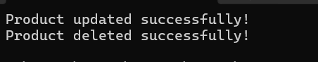
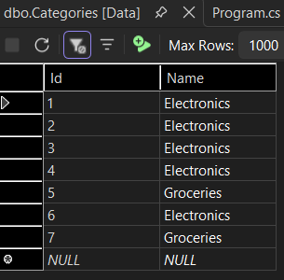
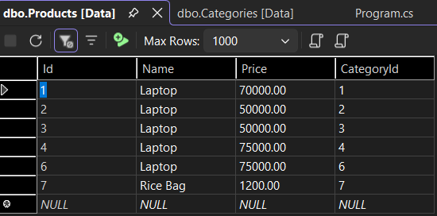
Lab 7: Writing Queries with LINQ
Program.cs
using Microsoft.EntityFrameworkCore;
namespace RetailInventory
{
internal class Program
{
static async Task Main(string[] args)
{
using var context = new AppDbContext();
// Filter products whose price is greater than 1000
var filtered = await context.Products
.Where(p => p.Price > 1000)
.OrderByDescending(p => p.Price)
.ToListAsync();
Console.WriteLine("Products costing more than ₹1000:");
foreach (var p in filtered)
{
Console.WriteLine($"{p.Name} - ₹{p.Price}");
}
Console.WriteLine();
// Project only Name and Price (DTO)
var productDTOs = await context.Products
.Select(p => new
{
p.Name,
p.Price
})
.ToListAsync();
Console.WriteLine("Product DTOs:");
foreach (var item in productDTOs)
{
Console.WriteLine($"{item.Name} - ₹{item.Price}");
}
}
}
}
